Validation and Test Case Generation for MSCs
using a Propositional SAT Solver

K. Meinke
Dept. of Numerical Analysis and Computer Science,
Royal Institute of Technology, 100 44 Stockholm,
and
Prover Technology AB, Alströmergatan 22, 112 47 Stockholm
e-mail: karlm@prover.com

2000-06-07

Abstract We describe the results of a pilot project to construct a validation and test case generation tool for MSCs based on a SAT solver for propositional logic known as Prover Plug-In™. We give a metric temporal logic semantics to MSCs which allows us to interface existing MSC editing tools to a constraint solver for metric temporal logic. In this way, we are able to use the results of constraint solving to carry out validation analysis of problems such as race and performance. The output from constraint solving can also be annotated and saved for the purposes of test case generation.

Introduction
Message Sequence Charts (MSCs) are gaining acceptance as a commercially useful requirements capture language for real-time and distributed systems, both within and outside the world of telecommunications. Similar formalisms, such as UML Sequence Diagrams, together with the spread of object-oriented software engineering (OOSE) further increase the interest in this type of formalism.

Independently of which systems development model is used (V model, spiral model etc.) there is a need for computer assistance with the validation activity during the requirements capture phase. By validation, we mean the (somewhat open-ended) activities of:

- investigating whether the user requirements as written down (typically in the form of MSCs and natural language text) coincide with the product that the end user actually wants, and

- certifying that the user requirements, as written down, are: internally consistent, unambiguous, complete (unless there is an intentional lack of information), and to the extent that this can be predicted at an early stage, technically feasible.

Well known statistics indicate the significant number and subsequent high-cost of errors which slip through the validation process.

It is important to distinguish between the process of validation, as described above, and the process of verification, where we check agreement between a set of requirements and an implementation. These differences between verification and validation reflect themselves in the different types of algorithms that are used for each. For verification one can apply automated reasoning (theorem proving) algorithms to compare an implementation with its requirements. This has been a traditional area of academic and industrial research into formal methods for many years. For validation of high-level requirements, it is not possible to carry out this kind of comparative analysis. On the other hand, simulating the system requirements can provide a rich source of information about the validity of a set of MSC requirements. In fact, by going beyond conventional state based simulation, and using constraint solving techniques such as those given by a SAT algorithm, we can obtain quite deep analyses of the information content of a set of MSCs. Such analyses, we claim, provide insight into the validation problem: “are we building the right system?”

In this paper we describe the results of a pilot project to develop validation and test case generation tools for MSCs using a commercially developed satisfiability algorithm. Prover Plug-In™ is a commercial implementation of Stålmarck’s satsifiability algorithm for propositional logic (Stålmarck [1989]), which is marketed by Prover Technology AB. We will describe an extension of Prover Plug-In that consists of a compiler from MSCs into temporal logic formulas. An existing application then allows us to compile the temporal logic model of a set of MSCs into propositional logic and execute the satisfiability algorithm. This algorithm either returns a satisfying assignment (that we decompile back into an MSC simulation) or a refutational proof (that can be returned for debugging purposes). Over a decade of industrial application, Stålmarck’s algorithm has proven itself to have efficient run-time and memory requirements, even though the satisfiability problem for propositional logic is NP-complete.

The structure of this paper is as follows. In Section 1 we outline the semantical model of MSCs that we use to carry out analysis. In Section 2, we explain the basic principles of compiling MSCs and validation properties into temporal logic formulas. Effectively, we give a semantics for MSCs using a metric temporal logic. In Section 3, we describe the architecture, functionality and performance of our MSC analysis tool. In Section 4, we briefly compare our approach to other MSC tool development projects described in the literature. Finally in Section 5 we present some conclusions.

1. Semantics of MSCs
In order to validate a set of MSCs it is first necessary to understand what they mean as a set of requirements, i.e. their semantics. Several different approaches to the semantics of MSCs can be found in the literature, including: Ladkin and Leue [1993, 1995], Mauw and Reniers [1994], Alur et al [1996] and Broy [1996]. The process algebraic semantics developed by Mauw has provided the basis for a standardised semantics proposed by the ITU in ITU [1995].

From the point of view of constraint solving, the most appropriate semantic model proposed in the literature seems to be the partial ordering semantics developed in Alur et al [1996]. Partial ordering semantics seems to come closest to capturing the informal semantics normally used to describe MSCs. From the point of view of tool use, this clear relationship between formal and informal semantics is very important. The requirements analyst must be able to understand the errors diagnosed by a tool in an intuitive way, in order to be able to correct them. Semantic models that are complex and unintuitive will hinder the effectiveness of any tool set that is built on top of them. In fact, Alur et al [1996] introduce a framework for different semantic models of MSCs. The fundamental constraints on the sending and receipt of messages can be extended in a variety of different ways, for example by making different assumptions about channel behaviours.

We will extend the semantic framework presented in Alur et al [1996] by introducing explicit simulations of MSCs as semantic objects. The aim is to automatically generate such simulations by constraint solving. Ultimately, we are even interested in timing and performance analysis. Therefore, our approach differs somewhat from Alur et al, since they place emphasis on efficient computation of the transitive closure of event orderings and use quite different algorithmic techniques for this.

  - Definition
A partial order model μ of a message sequence chart M is a structure consisting of:

- A finite non-empty set P of processes,

- A finite set E of events, which can be partitioned into two disjoint subsets,
S ⊆ E of send events and R ⊆ E of receive events,

- A labelling function L : E → P, which associates each event with the process where it occurs. (A send event occurs at the sending process, a receive event occurs at the receiving process.) Thus we can define the set E_{p} of events occurring at p, for each process p ∈ P, by
E_{p} = { e ∈ E | L(e) = p }

- A compatibility relation C ⊆ S × R, such that: (a) for each send event s ∈ S there exists at most one receive event r ∈ R such that C(s, r), and (b) for each receive event r ∈ R there exists at most one send event s ∈ S such that C(s, r).

- For each process p ∈ P, a total ordering < _{vis,p} ⊆ E_{p} × E_{p} on the (cartesian product of the) events occurring at p, called the visual order. The visual order < _{vis,p} represents the order in which the events at p appear visually, as drawn or written on the page. Since MSCs are normally drawn with the time axis moving down the page, then e₁ < _{vis,p} e₂ if, and only if, e₁ is drawn above e₂ in the diagram, or mentioned before e₂ in an equivalent MSC text specification. We let < _{vis} denote the corresponding (partial) visual ordering of all events,
<_{vis} = ∪_{p ∈ P} <_{vis,p} .

Notice that we have generalised the compatibility function of Alur et al [1996] to a compatibility relation C. This allows for the possibility, defined in the Z.120 MSC standard, that a sent message is “lost”, or that a received message is “found”. The partially one-to-one nature of the compatibility relation implies that at most one receive corresponds to any send, and vice versa.

The visual order of events occurring at any process can of course be misleading. The intended semantics of MSCs allows for other interleavings of events at a process that can also satisfy the same MSC. Thus the semantics of an MSC is “loose”. However, the semantics of an MSC is not totally without constraints. Certain causal relationships must be satisfied. In particular, no message can be received before it is sent. Furthermore, while no process has control over the order of receipt of messages (the environment alone determines this), a process does control the order in which it sends messages, and can even delay sending a message until a certain incoming message is received. These basic constraints are termed the enforced order in Alur et al [1996].

  - Definition
Let μ = ( P, E = S ∪ R, L, C, <_{vis} ) be a partial order model of a message sequence chart M. The enforced order <_{enf} ⊆ E × E on μ is the partial order of events defined by:

<_{enf} = ( ∪_{p ∈ P} <_{enf,p} ) ∪ C,

where, <_{enf,p} ⊆ E_{p} × E_{p} the enforced order at process p, is defined by:

e₁ <_{enf,p} e₂ ⇔ e₁ < _{vis,p} e₂ and e₂ ∈ S.

Thus, locally at each process, each send event must wait until all (visually) previous local events have occurred. Furthermore, globally, each receive event must wait until its corresponding send event (if any) has occurred.

The enforced ordering is the minimal ordering that every implementation of the MSC requirements must obey. One can wonder then, what remaining degrees of freedom exist for different implementations satisfying the same MSC? To explore the possibilities, we will introduce the concept of a simulation.

  - Definition
Let μ = ( P, E = S ∪ R, L, C, <_{vis} ) be a partial order model of a message sequence chart M, and let < ⊆ E × E be any partial order on the events of μ. (Intuitively < is a specific semantics for μ, such as the enforced order.) A simulation T : E → N for μ and < is any function that is compatible with <, or monotonic, in the sense that for any two events e₁, e₂ ∈ E.

e₁ < e₂ ⇒ T(e₁) < T(e₂),

where, on the right hand side, < is the usual arithmetic ordering on positive integers.

Intuitively, a simulation embeds the events of E in a discrete model of time in a way that is consistent with the ordering of events given by the semantics <. Notice that under a simulation T, we can say that two events occur simultaneously if T(e₁) = T(e₂). We note that other models of time besides the discrete, well-founded model given by the set N of natural numbers are possible here.

It is important to note that a simulation T for μ can reverse the visual ordering, in the sense that there can exist events e₁, e₂ ∈ E satisfying

e₁ <_{vis} e₂ but T(e₂) < T(e₁),

This is for example, possible if we take the semantics of μ to be the enforced ordering <_{enf}. This possibility of order reversal, between the visual ordering and the intended semantic ordering, is likely to be a significant source of errors during requirements capture and analysis. In a sense, the simple graphical structure of MSCs can be misleading for the unwary.

One can wonder whether the embedding of events into discrete time, given by a simulation, introduces too much detail. A more abstract approach might be to consider partial orders that refine the intended semantic order. However, in practise, we can generate simulations over very short time intervals, such that very little redundant information is introduced. Furthermore, by considering concrete timed simulations rather than abstract refined partial orders, we make way for the possibility of using more fine grained semantics to explore timing, queuing and performance issues already at a high level.

  - Queuing Analysis
As we have already observed, it is possible to envisage high-level constraints on the intended implementations of an MSC, or set of MSCs. In particular, we can postulate constraints on the communication channels between processes. These may be qualitative, e.g. the constraint that a channel between two processes behaves as a first-in first-out (fifo) queue or that a channel is lossy. They may also be quantitative, e.g. the constraint that a channel has a bounded capacity, or a certain delay time.

As an example, let us consider a qualitatively refined semantics that allows for the possibility to specify an arbitrary subset of fifo channels.

1.5. Definition
Let μ = ( P, E = S ∪ R, L, C, <_{vis} ) be a partial order model of a message sequence chart M, and let <_{enf} ⊆ E × E be the enforced ordering on μ. Let FIFO ⊆ P × P be a binary relation between pairs of processes termed the FIFO channel definition. Intuitively a pair (p, q) ∈ FIFO if, and only if, the channel from process p to process q obeys the strict first-in first-out scheduling rule. (We explain this semantically below.)

The enforced FIFO order <_{FIFO} ⊆ E × E on events is the least partial order that extends the enforced order <_{enf} and that satisfies

s₁ <_{FIFO},_{p} s₂ & C(s₁, r₁) & C(s₂, r₂) ⇒ r₁ <_{FIFO},_{q} r₂ (FIFO axiom)

for all pairs (p, q) ∈ FIFO and for all events s₁, s₂ ∈S, and all r₁, r₂ ∈R. Here <_{FIFO},_{p} denotes the restriction of <_{FIFO} to the events occurring at process p, i.e.

<_{FIFO},_{p} = <_{FIFO} ∩ E_{p} × E_{p}.

Notice that in the channel definition we do not assume that a communication channel is fifo in both directions, i.e. (p, q) ∈ FIFO does not imply (q, p) ∈ FIFO. This symmetry requirement must be specified explicitly in the channel definition. Thus the enforced FIFO order is actually a parameterised family of semantics, one for each possible FIFO channel definition. Obviously this channel definition lies outside the notational scope of the MSCs. The end user must add such information interactively, using the analysis tool.

Notice also that <_{FIFO} is a well defined relation, i.e. a least such partial order exists, since the intersection of two partial order extensions of <_{enf} satisfying (FIFO axiom) is again a partial order extension of <_{enf} satisfying (FIFO axiom). In the case that FIFO is the empty set, i.e. no channels are fifo, then the enforced FIFO order is simply the enforced order.

  - Timing Analysis
The FIFO channel semantics of Definition 1.5 is just one of a variety of ways to refine the semantics of MSCs qualitatively. It is also interesting to refine the semantics of an MSC quantitatively. One simple refinement is to introduce a concept of channel delays.

  - Definition
Let μ = ( P, E = S ∪ R, L, C, <_{vis} ) be a partial order model of a message sequence chart M, and let < ⊆ E × E be a partial ordering on the events of μ. Let δ : P × P → N be a binary channel delay function which specifies, for each pair of processes (p, q), the time delay between messages sent from p to q. (Once again, we do not necessarily assume that the channel between p and q is symmetric, i.e. we allow that δ (p, q) ≠ δ (q, p) .) A simulation T : E → N for μ, < and δ is a simulation for μ and < which satisfies the channel delay function δ in the sense that for any compatible send s ∈ S and receive r ∈ R (i.e. where C(s, r)), if L(s) = p and L(r) = q then

T(r) – T(s) = δ (p, q) ,

i.e. the delay between the send event s at p and the receive event r at q satisfies the specified channel delay δ (p, q) between p and q.

Notice that this definition is orthogonal to the underlying semantics < assumed for μ, i.e. we can choose different underlying event orderings < (e.g. FIFO versus non-FIFO) for the same collection of channel delays.

2. Analysis and Validation Concepts
Our concept for an MSC analysis tool was to use a constraint solving algorithm to allow the requirements analyst to automatically generate and visualise simulations. As can be seen from the semantic models introduced in Section 1, at the very least one needs to be able to generate partial orders that are consistent with, and extend, a given partial order that represents the semantics of an MSC. For quantitative and performance analysis, we need to be able to go beyond this and generate timed simulations which satisfy the semantics of an MSC, in the manner described in Section 1.

In Section 3, we will describe the architecture and performance of a tool that automatically generates simulations of an MSC, according to different semantic models. This tool is based on the idea of compiling an MSC (or a set of MSCs) under a given semantics, into a set of temporal logic formulas. Using constraint solving, the tool is able to automatically generate and visually represent simulations, in the sense of Section 1.

In this section, we describe in a more abstract way the construction of the MSC analyser, by considering the basic compilation ideas given by the underlying temporal logic. Effectively, we give a semantics for MSCs in terms of temporal logic. Our aim is to clarify which kinds of MSC semantics can be supported (implemented as different compiler options) and what kinds of validation queries are possible using the MSC tool.

The temporal logic that is the target for compilation of an MSC, is a metric temporal logic known as TRIO, originating in Morzenti et al [1992]. In a metric temporal logic both the relative ordering and the absolute sequencing of events in time can be expressed. The full TRIO language is very rich and expressive, and includes modularisation facilities and specification structuring ideas that are unnecessary for our approach. With regard to the MSC semantics discussed in Section 1, it suffices to consider just the propositional fragment of TRIO, known as propTRIO.

A propTRIO formula, is a formula built up starting from propositional literals, p, q, etc, using the propositional connectives & (and), | (or), ~ (not) and -> (implies). In addition, the language allows integer expressions to be built up in the usual way from integer constants 0, 1, -1, … and variables chosen from some set X, and the usual arithmetic operations, +, -, *. Then, if exp₁ and exp₂ are integer expressions,

( exp₁ < exp₂ ), ( exp₁ = exp₂ )

are both propTRIO formulas. Furthermore, if φ is a propTRIO formula, and exp is an integer expression, then

Dist( φ, exp )

is a propTRIO formula. The operator Dist is termed the distance or shift operator. Intuitively, the truth value of Dist(φ, exp) at time t is the truth value of φ shifted a distance of exp time units from t. Finally, since the integer expression exp may contain variables, we would like to be able to quantify over these, so that temporal modalities can be expressed. Thus if φ is a propTRIO formula, and x is an integer variable, then

( ∀x φ ), ( ∃x φ )

are propTRIO formulas.

A temporal structure S for this language, consists of a family of functions p_{S} : Z → B, one for each propositional literal p, where Z = { … , -1, 0, 1, 2, … } denotes the set of integers, and B = { true, false } denotes the set of Booleans. Then for each propTRIO formula φ, and for any temporal structure S, any integer variable assignment α : X → Z, and any temporal instant i ∈ Z, we can define the satisfaction relation (S, α, i) |= φ, (read “φ is true in S under α at time i”) by induction on the complexity of formulas,

(S, α, i) |= p ⇔ p_{S}(i) = true,

(S, α, i) |= ( exp₁ < exp₂ ) ⇔ eval_{α}(exp₁) < eval_{α}(exp₂)

(S, α, i) |= ( exp₁ = exp₂ ) ⇔ eval_{α}(exp₁) = eval_{α}(exp₂)

(S, α, i) |= ( φ & ψ ) ⇔ (S, α, i) |= φ and (S, α, i) |= ψ

(S, α, i) |= ( φ | ψ ) ⇔ (S, α, i) |= φ or (S, α, i) |= ψ

(S, α, i) |= ~ φ ⇔ not (S, α, i) |= φ

(S, α, i) |= ( φ -> ψ ) ⇔ (S, α, i) |= φ implies (S, α, i) |= ψ

(S, α, i) |= Dist( φ, exp ) ⇔ (S, α, i + eval_{α}(exp) ) |= φ

(S, α, i) |= ( ∀x φ ) ⇔ (S, α[x/j], i) |= φ for all j ∈ Z,

(S, α, i) |= ( ∃x φ ) ⇔ (S, α[x/j], i) |= φ for some j ∈ Z,

Here, eval_{α}(exp) is the integer value obtained by evaluating the expression exp under the assignment α : X → Z recursively, while α[x/j] : X → Z is the variable assignment which agrees with α everywhere except on x, where α[x/j](x) = j. Notice above how the distance operator Dist( . , . ) shifts the evaluation of its formula argument.

The advantage of having a temporal language with a single shift operator is that we can use it to encode most of the commonly used temporal modalities. To compile MSCs into propTRIO in a semantically transparent way, we require the following modalities:

Always( φ ) ≡ ∀x Dist( φ , x)

Sometime( φ ) ≡ ∃x Dist( φ, x)

SometimeFuture( φ ) ≡ ∃x ( x > 0 & Dist( φ, x) )

AlwaysFuture( φ ) ≡ ∀x ( x > 0 -> Dist( φ, x) )

Before( φ, ψ ) ≡ Always( φ -> SometimeFuture(ψ ) )

OccursOnce( φ ) ≡ Always ( φ -> AlwaysFuture( ~ φ ) )

Within( φ, exp ) ≡ ∃x ( x < exp & Dist(φ, x) )

It is instructive to decode these modalities according to the semantics given above. For example, Before( φ, ψ ) means that for any integer time point i ∈ Z, if φ is true at i, then at some point in the future relative to i, ψ is true. OccursOnce( φ ) means that for every integer time point i ∈ Z, if φ is true at time i then ~ φ is true for ever in the future after i.

With these operators formalised, we can give a metric temporal logic semantics to an MSC which coincides with its partial ordering semantics, for the various different semantic models proposed in Section 1.

2.1. Definition
Let μ = ( P, E = S ∪ R, L, C, <_{vis} ) be a partial order model of a message sequence chart M, and let < ⊆ E × E be a semantics or partial ordering of events on μ. The metric temporal logic semantics of μ and < is given by the propTRIO formula

Sem_{μ,<} ≡ Always( Before_{μ,<} & Uniqueness_{μ} ),

where the subformulas Before_{μ} and Uniqueness_{μ} are defined by:

Before_{μ,<} ≡ &_{( e1, e2 ) ∈ <} ( Before( e₁, e₂ ) )

and

Uniqueness_{μ} ≡ &_{e ∈ E} ( Sometime( e ) & OccursOnce( e ) )

Intuitively, Before( e₁, e₂ ) captures the property that e₁ occurs before e₂ in the semantic ordering, i.e. e₁ < e₂, while Before_{μ,<} is the conjunction of all such facts. Also Sometime( e ) and OccursOnce( e ) express the fact that the event e occurs once and only once. Thus Uniqueness_{μ} is the conjunction of all such facts.

Notice how this temporal logic semantics is parameterised by the partial ordering semantics given by the relation <. This is explicitly seen in the formula Before_{μ,<}. Thus we may choose < to be the enforced partial ordering, one of the possible enforced FIFO orderings (according to a set of FIFO channel definitions), or any other semantics. For example, we could relax the constraint Sometime( e ) on receive events e in order to model a lossy channel.

It is also possible to refine the above temporal logic semantics with quantitative constraints, such as channel delays. For this we make essential use of the fact that propTRIO is a metric temporal logic, with which temporal distances can be specified. Recall again Definition 1.7.

2.2. Definition
Let μ = ( P, E = S ∪ R, L, C, <_{vis} ) be a partial order model of a message sequence chart M, and let < ⊆ E × E be a partial ordering on the events of μ. Let δ : P × P → N be a binary channel delay function. The metric temporal logic semantics of μ and < is given by the propTRIO formula

Sem_{μ,<,δ} ≡ Always( Timing_{δ} & Uniqueness_{μ} ) ,

where Uniqueness_{μ} is defined as in Definition 2.1 and the formula Timing_{δ} is given by

Timing_{δ} ≡ &_{(p, q) ∈ P×P}, Timing_{δ,(p,q)}

where letting

mess(p, q) = { (s, r) ∈ E² | s ∈ E_{p} and r ∈ E_{q} and C(s, r) }

i.e. mess(p, q) is the set of all compatible send/receive pairs (s, r) from process p to process q, then we define

Timing_{δ,(p,q)} ≡ &_{(s, r) ∈mess(p, q)} ( s -> Dist( r, δ(p, q) )

Intuitively the formula Timing_{δ,(p,q)} forces all messages from p to q to incur a delay of exactly δ(p, q) units. Notice that the formula Timing_{δ} subsumes the formula Before_{μ,<} in the sense that every temporal structure S which satisfies Timing_{δ} also satisfies Before_{μ,<}.

Many different generalisations and refinements of this timed delay semantics are possible. For example, we can specify a channel delay of no more than δ₁(p, q) time units, or no less than δ₂(p, q) time units (or even both). We leave this as an exercise for the interested reader.

Given an MSC M, its partial ordering semantics <, any associated channel delay information δ, and the corresponding temporal logic semantics φ we can consider generating temporal structures which satisfy φ according to the satisfaction relation |= defined above. However, such structures are infinite, and therefore can neither be generated nor stored in the finite memory of a computer. Nevertheless, it is possible to approximate the infinite model semantics of propTRIO with a finite model semantics, in a way that preserves the validity of the kinds of formulas we are usually interested in. A finite model semantics defines the truth values of literals over a contiguous but finite segment of the infinite timeline. Such a semantics can be defined in various different ways. The approach used in the temporal logic front end to Prover Plug-In is defined in Morzenti et al [1992].

What is the utility of generating such satisfying temporal structures? At the very least we can say that each such structure provides an abstract simulation of a possible implementation of the system. Simulation alone is often enough to debug the more obvious errors in a set of requirements, such as errors of omission. On the other hand, the number of satisfying temporal structures is likely to be extremely large, and random exploration of this space becomes less productive as the space grows. Instead, we would like to add further constraints that force requirements errors to manifest themselves within simulations. Let us describe two such examples.

As we have already discussed in Section 1, a deceptive aspect of the graphical structure of an MSC is that the visual ordering that it implies may disagree with the actual semantic ordering. Thus we can consider focussing on those temporal structures for which the visual ordering disagrees with the semantic ordering.

2.3. Definition
Let μ = ( P, E = S ∪ R, L, C, <_{vis} ) be a partial order model of a message sequence chart M, and let < ⊆ E × E be a semantics or partial ordering of events on μ. The visual ordering query is given by the propTRIO formula

Visual_{μ,<} ≡ Sem_{μ,<} & ( | _{(p, q) ∈<vis} ~ Before( p, q) )

Each temporal structure which satisfies the query Visual_{μ,<} is a temporal structure that satisfies the semantic ordering < on events, but not the visual ordering <_{vis} on events. Generating simulations for this constrained formula allows us to focus on breaches of the visual ordering. Therefore this focussed simulation is more likely to uncover requirements errors than randomly simulating the semantics Sem_{μ,<} alone. On the other hand, requirements errors may also stem from other sources, so we must also consider other ways to constrain the basic semantic formula Sem_{μ,<} .

Other ways to constrain the semantic formula Sem_{μ,<} come from performance analysis. We have already seen, in Section 1, a refined semantics Sem_{μ,<,δ}, based on a model of channel delays. It can be interesting to formulate queries about global performance, in the presence of local channel performance constraints. A simple example is: “is it possible that the total execution time for an MSC exceeds a certain bound?” Note that this query assumes we can identify definite start and end events for the MSC.

2.4. Definition
Let μ = ( P, E = S ∪ R, L, C, <_{vis} ) be a partial order model of a message sequence chart M, and let < ⊆ E × E be a partial ordering on the events of μ. Let δ : P × P → N be a binary channel delay function. Let start, end ∈ E be the first and last events for the MSC. (These must be explicitly declared.) For any positive integer d ≥ 0, the delay bound query is given by the propTRIO formula

Delay( start, end, d ) ≡ Sem_{μ,<,δ} & Sometime( start & ~ Within( end, d ) )

where start, end ∈ E are the first and last events for the MSC. (These must be explicitly declared.)

Each temporal structure which satisfies the query Delay( start, end, d ) is a temporal structure that qualifies as a correctly timed simulation of M in terms of local channel delays (i.e. it satisfies Sem_{μ,<,δ}). However the simulation as a whole takes an execution time exceeding d. Thus if we can produce such a simulation by constraint solving, we may be able to diagnose why the interaction of the MSC components lead to an excessive total execution time. Again, one can think of many refinements and generalisations of this kind of constraint on the basic semantic model Sem_{μ,<,δ}.

3. Tool Development
Our methodological approach to MSC validation consists of identifying specific validation queries that can be modelled as temporal logic constraints. These queries can be selected by the end-user from a fixed menu of options. The corresponding temporal logic constraints are then automatically added at compile time to the basic temporal logic model (the enforced order on events) to carry out “pre-packaged” analyses. An alternative approach would be to allow the end-user to directly add temporal logic constraints to the underlying model. This latter approach supports maximum tool flexibility, but incurs the rather high overhead that the end user needs to learn another requirements capture language, namely temporal logic. In addition, we think that this approach can make the validation exercise error prone, if the wrong constraint formula is mistakenly added.

As well as considering the front-end user interface design, we must also consider the back-end user interface: how can we display the results of analysis in a meaningful form? In this case, for a pilot study, we made use of an existing constraint solving tool for the TRIO temporal logic, which has its own graphic visualisation tool. The question of an optimal visualisation of validation results is still the subject of ongoing research.

In this section, we will briefly describe the internal architecture and fundamental algorithms of our analysis tool. We will also illustrate the tool output, in the form of screen shots, to give a more concrete understanding of what kind of information an analysis produces.

  - Tool Algorithms and Architecture
The MSC analysis tool has a layered architecture, which allows maximum re-use of existing formal analysis tools including: a propositional logic SAT solver (Prover Plug-In), an optimising compiler from many-sorted first order logic over finite domains into propositional logic (MSFOL2PROP), and an optimising compiler from the temporal logic TRIO into many-sorted first order logic. The tool architecture is summarised in Figure 1.

The input to the MSC analysis tool is an MSC file, in text format, satisfying the Z.120 ITU syntax standard. Any tool, which conforms to this standard, can be used as an MSC editing tool in Figure 1.

The different semantic translations from MSCs into propTRIO, some of which were described in Section 2, are contained within the package MSC2TRIO. This package can be viewed as a compiler from MSCs into the TRIO syntax. The different validation constraints, that can be selected by the end user, are accessed by using different compiler options. The output of MSC2TRIO is a set of propTRIO temporal logic formulas.

These temporal logic formulas are then fed in to an existing temporal logic kernel for the TRIO language. This tool is actually the product of an earlier Esprit research project (project 25581 FAST) into constructing a requirements analysis and test case generation tool for the full TRIO language. The temporal logic kernel consists of a layered set of optimising compilers, from TRIO into many-sorted first order logic (TRIO tool), and from many-sorted first order logic into propositional logic (MSFOL2PROP). At the bottom of this compilation hierarchy lies the Prover Plug-In SAT solver for propositional logic. This algorithm is able to generate both refutational proofs for an inconsistent set of propositional formulas, and satisfying assignments for a set of satisfiable propositional formulas. In the case that a satisfying assignment is constructed, this assignment is then decompiled, by MSFOL2PROP, into a satisfying assignment for the original set of first order formulas. The MSFOL satisfying assignment is then decompiled by the TRIO tool into a finite temporal stucture for the original set of TRIO formulas, in the sense of Section 2. Finally, the visualisation tool within the temporal logic kernel allows one to view the resulting temporal structure in graphic format. (We illustrate this format in Section 3.2.)

The underlying SAT solver, Prover Plug-In, has the greatest overall effect on the run-time and memory requirements of the MSC analysis tool. This package is an implementation of Stålmarck’s algorithm (Stålmarck [1992]) for checking satisfiability of propositional formulas, though it also provides a constraint solving capability for quantifier free arithmetic formulas. Stålmarck’s algorithm has been described elsewhere in the literature, e.g. Sheeran and Stålmarck [1998], and we will not give a detailed description here. It suffices to say that the algorithm is based on a specific natural deduction calculus for propositional logic, which introduces a notion of the structural complexity of proofs. The algorithm acts as a refutational theorem prover, by enumerating proofs according to their structural complexity. The search for a refutational proof is interleaved with the search for a satisfying assignment to the propositional variables of the input formula. Prover Plug-In has been used in industry for over ten years. The algorithm has been shown to be both efficient and, in many contexts, scalable to large input sizes. The largest industrial application to date, an analysis of railway interlockings, has solved satisfiability problems with over 100,000 propositional variables and 300,000 propositional formulas.

MSC EditingTool

MSC Text

MSC Analysis Tool
MSC2TRIO

TRIO Tool
Visualisation Tool

MSFOL2PROP

Prover Plug-In SAT
Temporal Logic Kernel

Figure 1: Architecture of the MSC analysis tool

3.2. Simulation Output
In this section, we illustrate the output results from the MSC analysis tool. We shall consider the validation problem of identifying simulations which are inconsistent with the visual ordering, i.e. the validation query Visual_{μ,<} of Definition 2.3. Consider the following simple MSC chosen to exhibit a potential race between the receipt of message mess1 and the receipt of message mess3 at process P1.

Under compilation, the events of sending mess1, mess2, and mess3 are encoded as events s1, s2 and s3 respectively, while the receipts are encoded as events r1, r2 and r3. Satisfying the basic semantic query, i.e. the enforced ordering formula Sem_{μ,<enf} of Definitions 1.2 and 2.1, immediately yields a simulation that follows the visual ordering. This is shown in Figure 2. This figure graphically displays a finite temporal structure of 15 time steps. The occurrence of each event s1 (send mess1) r1 (receive mess1) etc, are indicated by Boolean values. Thus s1 occurs at time 1, r1 at time 2, etc. Clearly r3 occurs after r1 in this simulation, thus the entire simulation follows the visual ordering of Figure 1.

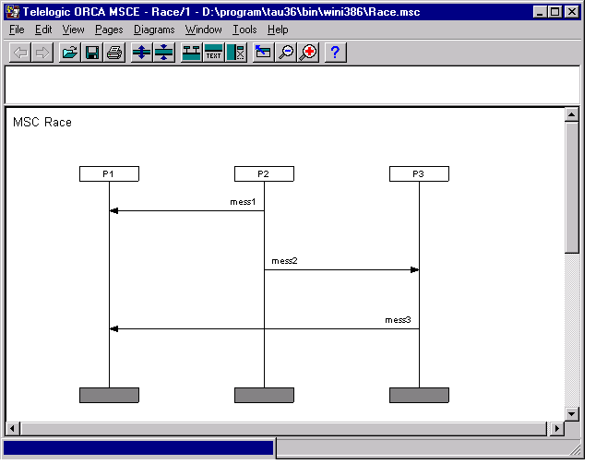
Figure 1: A simple MSC with potential race

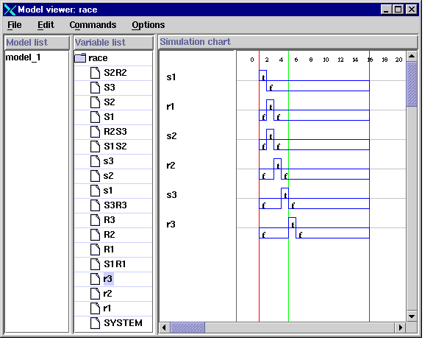
Figure 2: A simulation for query Sem_{μ,<enf} consistent with the visual ordering

To obtain a simulation which reverses the visual ordering of Figure 1, but is consistent with the enforced ordering we satisfy the refined query Visual_{μ,<enf}, as defined in Definition 2.3. This immediately produces the simulation of Figure 3. Observe how r1 now occurs after r3.

The MSC analysis tool can also be used to annotate and save simulations in tabular form suitable for subsequent system test. Thus it can function as a test case generator. A full description of this functionality requires a lengthy explanation of testing procedures. Therefore our main results will be described elsewhere. However, to indicate here the possibilities, we show a test case constructed for a simple communication channel with non-deterministic but bounded delay in Figure 4. This table is based on extracting externally visible events, consisting of input test data, and resulting validation output data. It is necessary to annotate the MSC, via the MSC analysis tool, in order to distinguish between external and internal events.

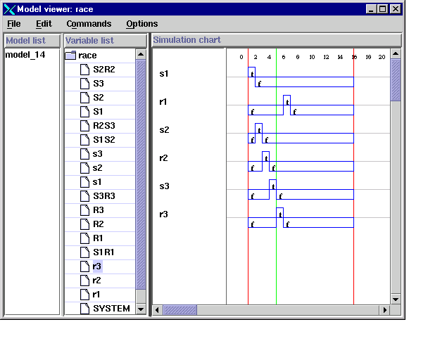
Figure 3: A simulation for query Visual_{μ,<enf} inconsistent with visual ordering

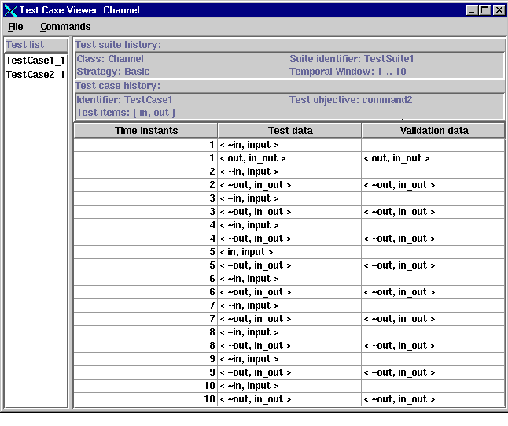
Figure 4: A test case table for a bounded delay channel.

4. Related Systems
Most closely related to our own approach, is the work of Alur et al [1996]. This work presents an analysis tool for MSCs based on similar kinds of partial order models of MSCs to those discussed in Section 1. The underlying algorithms for the tool include an efficient algorithm for computing the transitive closure of a partial order which is more efficient than the standard Floyd-Warshall algorithm, and achieves an O(n²) performance, where n is the number of events.

It is somewhat difficult to produce a similar worst-case complexity analysis for our own approach, since the time complexity of Stålmarck’s algorithm is determined by the structural complexity of a minimally complex refutational proof. This structural complexity is independent of the number of propositional literals, (which in this case will be proportional to the number of MSC events). It is this independence that leads to the scalability of the algorithm for large problem sizes, in certain contexts. Under these circumstances, it seems only possible to benchmark our tool against existing analysis tools for specific case studies. This is also a subject of ongoing research.

We note that Alur et al [1996] also considers performance analysis of the kind discussed in Section 2. For this, standard graph theoretic algorithms seem to have been used, such as computing negative cost cycles, and shortest paths by dynamic programming. These algorithms _{achieve} O(n³) performance, and illustrate the greater computational effort required to achieve quantitative rather than qualitative results.

5. Conclusions
In this paper we have presented the results of a pilot study into constructing an MSC validation and test case generation tool, based on a metric temporal logic semantics for MSCs and an efficient SAT solver for propositional logic. We claim that this tool provides great flexibility, by virtue of the fact that many different kinds of validation analysis can be expressed as temporal logic constraints on the basic MSC semantics.

Open research problems for the future include benchmarking against other kinds of algorithms, assembling a wider collection of validation queries, and developing more appropriate graphical user interfaces to present the results of validation analyses. These will be described in a future report.

References
R. Alur, G.J. Holzmann and D. Peled, An analyser for Message Sequence Charts, 35-48 in T. Margaria and B. Steffen (eds) Proc. TACAS ’96, LNCS 1055, Springer Verlag, 1996.
M. Broy, On the Meaning of Message Sequence Charts, tech report, Technical University of Munich, 1996.
P. Graubmann, E. Rudolph, J. Grabowski, Towards a Petri Net based semantics definition for message sequence charts, in O. Faergemand and A. Sarma (eds) Proc. of the 6th SDL Forum, SDL ’93, 1993.
ITU, ITU-T Recommendation Z.120, Annex B: Algebraic Semantics of Message Sequence Charts, ITU-Telecommunications Standardisation Sector, Geneva, 1995.
P.B. Ladkin and S. Leue, Interpreting Message Sequence Charts, Technical Report TR 101, Dept. of Computing Science, University of Sterling, 1993.
P.B. Ladkin and S. Leue, Interpreting Message Flow Graphs, Formal Aspects of Computing, 7(5), 473-509, 1995.
S. Mauw and M.A. Reniers, An algebraic semantics of basic message sequence charts, The Computer Journal, 37(4), 1994.
A. Morzenti, D. Mandrioli and C. Ghezzi, A model parametric real-time logic, ACM Transactions on Programming Languages and Systems,14(4), 521-573, 1992.
B. Selic, Automatic Generation of Test Drivers from MSC Specs, internal technical report TR 960514, ObjecTime Ltd, 2000.
M. Sheeran and G. Stålmarck, A tutorial on Stålmarck’s proof procedure for propositional logic, in: Proc. Int. Conf. On Formal Methods in Computer-Aided Design (FMCAD ’98), LNCS, 1998.
G. Stålmarck, A System for Determining Propositional Logic Theorems by Applying Values and Rules to Triples that are Generated from a Formula, Swedish Patent No. 467 076 (approved 1992), US Patent No. 5 276 897 (1994), European Patent No. 0403 454 (1995).

